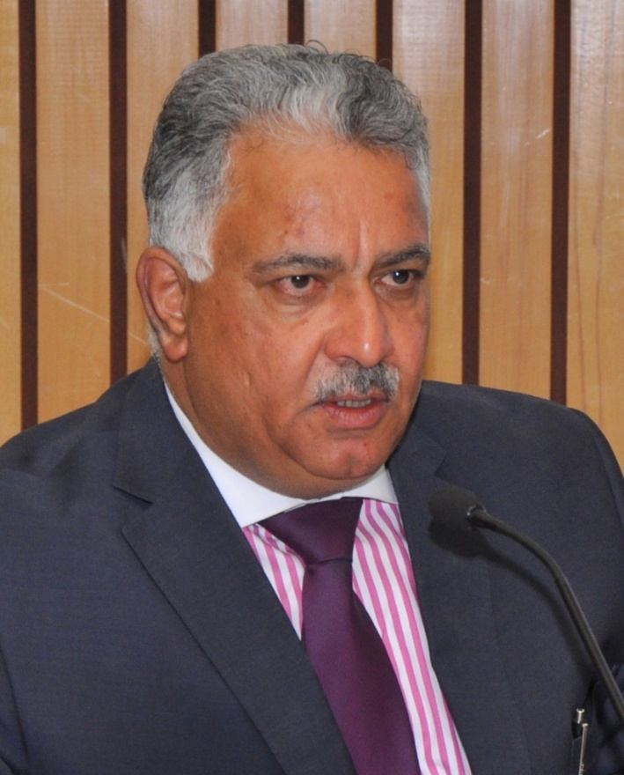
Anil Malhotra

Webinars Participation

These sessions can be viewed by clicking on Discussions on International Family Law on the website (Work Page) and are also you can directly view the videos on Youtube channel - Chambers of Advocate, Anil Malhotra

- Conducted Webinar for Journey Beyond Law - CLC- 1, Chandigarh. Spoke, elaborated and discussed issues relating to "INTER-PARENTAL CHILD REMOVAL - RIGHTS AND REMEDIES" on April 19, 2020.

- Conducted Law Webinar organised by Guru Nanak Dev University, Amritsar and lectured as keynote speaker on "CHILD CUSTODY: SOCIO-LEGAL ISSUES- THE FUTURE," on April 24, 2020. Concluding observations were given by Justice A.K. Sikri, Former Judge, Supreme Court.

- As Author, Legal Commentator & Analyst, addressed Webinar for Lawyers from State of Maharashtra on "PARENTAGE, CHILD CUSTODY,GENDER& EQUALITY - SOCIO-LEGAL PERSPECTIVES," on April 27, 2020.

- Addressed JGLS Webinar on “THE RIGHTS OF THE CHILD IN INTERNATIONAL PARENTAL CHILD REMOVAL CONFLICT,” for students and faculty of Jindal Global University, Sonipat on May 16, 2020.

- Addressed Bar Council of Punjab and Haryana Virtual Dialogue Session with HMJ HimaKohli and HMJ Alistair MacDonald on “FAMILY LAW: ISSUES AND THE WAY AHEAD IN COVID-19 TIMES,” on June 6, 2020.

- Addressed “Beyond CLC” Webinar on “THE VULNERABILITY OF CHILDREN AND LAW” with Ms. Justice RoshanDalvi and Ms. Justice ShaliniPhansalkar Joshi and spoke on Child support and custody on June 27, 2020.

- Addressed International Webinar on “CONTEMPORARY ISSUES IN PRIVATE INTERNATIONAL LAW WITH SPECIAL REFERENCE TO THE OUTBREAK OF COVID-19” for National University of Advanced Legal Studies (NUALS) Kochi on July 4, 2020.

- Addressed Webinar on “INTERNATIONAL FAMILY LAW IN VIRTUAL WORLD” for Amity Law School, Amity University, Kolkata on July 10, 2020.

- Virtual Book launch of “THE GLOBAL INDIANS AND THE LAW,” hosted by Bar Council of Punjab and Haryana and released by Hon’ble Ms. Justice Indu Malhotra, Hon’ble Mr. Justice A.K. Sikri and Mr. Soli J. Sorabjee on August 29, 2020.

- As Resource Person Addressed Webinar on September 11, 2020 on “ALL ABOARD SURROGACY EXPRESS,” held under the AEGIS of Human Resource Development Centre, JamiaMillliaIslamia University, New Delhi, Refresher Course on Human Rights and Social Inclusion, for all India faculty members of Colleges and Universities, held from September 7 to September 19, 2020.

- Virtual Book launch and discussion on “THE GLOBAL INDIANS AND THE LAW,” hosted by Symbiosis Law School, Pune. Panelists Hon’ble Justice Dr. S. Murlidhar, Dr. ShashikalaGurpur, Mr. Narinder Singh and Ms. ReshmaSambare on October 3, 2020.

- For M/s ShyamPadman Associates 169th “Legal Empowerment through interaction-Lecture Series” (LETILS-169), addressed webinar on “INTER PARENTAL CHILD REMOVAL – AN EVOLVING JURISPRUDENCE,” held on January 16, 2021.

- For Centre for the Study of United Nations & Jindal Society of International Law Lecture Series,on February 4, 2021,addressed online inaugural session on “GLOBAL FAMILY LAW – INTERNATIONAL PERSPECTIVES” andspoke on “GLOBAL INTERNATIONAL FAMILY LAW IN INDIA – A DILEMMA”.

- For Ayushman Initiative addressed webinar on “PARENTAL ALIENATION, LAW COMMISSION REPORT AND THEIR CORRELATION TO CHILD ISSUES,” on February 19, 2021.

- For M/s ShyamPadman Associates 180th “Legal Empowerment through interaction-Lecture Series” (LETILS-180), addressed webinar on “LIVE & LET LIVE IN HARMONY – INTER-FAITH MARRIAGES,” on February 20, 2021.

- Addressed Online Lecture on “SECURING THE SERVICES OF EXPERTS UNDER FAMILY COURTS ACT, 1984” and “TRIAL OF MATTERS WHERE PARTIES ARE LIVING IN DIFFERENT JURISDICTIONS PARTICULARLY WHERE ONE OF THE PARTIES IS RESIDING IN A FOREIGN COUNTRY” on February 27, 2021 for an online training programme for Principal / Additional Judges of Family Courts in the State of Uttar Pradesh, conducting by Judicial Training and Research Institute, U.P.

- For M/s ShyamPadman Associates 188th “Legal Empowerment through interaction-Lecture Series” (LETILS-188), addressed webinar on “CHILD IS THE FATHER OF MAN– CONFRONTING CHILD CUSTODY CONFLICTS,” on March 20, 2021.

- For M/s ShyamPadman Associates 193rd “Legal Empowerment through interaction-Lecture Series” (LETILS-193), addressed webinar on “ALL ABOARD FOR THE FERTILITY EXPRESS-SURROGACY AND THE LAW,” on April 4, 2021.

- For M/s ShyamPadman Associates 195rd “Legal Empowerment through interaction-Lecture Series” (LETILS-195), discussion and book review of “GLOBAL INDIANS AND THE LAW.” Panelists Hon'ble Mr. Justice A MuhamedMustaque, Judge, High Court of Kerala, Prof (Dr) Balram K Gupta, and Ms. MrunaliniDeshmukh, on April 11, 2021.

- Delivered lecture series on“PRIVATE INTERNATIONAL LAW AND FAMILY DISPUTES” to Master of Law Students at Symbiosis International (Deemed University), Pune from March to May 2021.

- For Maharashtra National Law University, Mumbai, in association with Family Court Bar Association, Mumbai, addressed webinar on “ALIENATION & SHARED PARENTING – ISSUES, CHALLENGES & SOLUTIONS,” on May 21, 2021.

- For M/s ShyamPadman Associates 206th “Legal Empowerment through interaction-Lecture Series” (LETILS-206), addressed webinar on “LOVING CHILDREN YET TO MEET- DOS AND DON’TS OF ADOPTIONS,” on May 23, 2021.

- Child Law National online Moot Court Competition 2021, on June 17 and 18, 2021. Hosted by Army Institute of Law (AIL) and Malhotra and Malhotra Associates. Discussed, deliberated and judged competition on “INDIA, INTER PARENTAL CHILD REMOVAL ISSUES” in mock courts.

- For Sai University, Chennai, addressed webinar on “INTERNATIONAL CHILD CUSTODY LITIGATION- A QUAGMIRE,” on July16, 2021.

- For M/s ShyamPadman Associates 232th “Legal Empowerment through interaction-Lecture Series” (LETILS-232), addressed webinar on “PUTTING THE CART BEFORE THE HORSE – A FLAWED AMENDMENT OF ADOPTION LAWS,” on August 7, 2021.

- For M/s ShyamPadman Associates 238th “Legal Empowerment through interaction-Lecture Series” (LETILS-232), addressed webinar on “ANTI-INJUNCTION SUITS- A CRITIQUE WITH SPECIAL EMPHASIS ON FAMILY COURTS ACT,” on September 5, 2021, presided by Hon’ble Mr. Justice A. Mohamed Mustaque, Judge High Court of Kerala.

- Book Launch and Panel Discussion webinar of “THE GLOBAL INDIANS AND THE LAW,” hosted by OP Jindal Global University, Jindal Global Law School on September 10, 2021.

- For M/s ShyamPadman Associates 239th “Legal Empowerment through interaction-Lecture Series” (LETILS-232), addressed webinar on “CHILD ADOPTIONS- A ZIG-ZAG TRAJECTORY,” on September 11, 2021, presided by Hon’ble Mr. Justice C. S. Dias, Judge High Court of Kerala.

- “PARENTING 4.0 – HAS INDIAN FAMILY COURT SYSTEM FAILED OUR CHILDREN?”. Virtual panel discussion hosted by BambooTree Children’s Foundation and Child Rights Foundation on October 2, 2021.

- Lectured on “GLOBAL SKILLS AND LEGAL PRACTICE,” online to the pupils of Bachelor of Laws Degree Course at Symbiosis International University at Pune on November 27, 2021.

- For M/s ShyamPadman Associates 264th “Legal Empowerment through interaction-Lecture Series” (LETILS-264), addressed webinar on “GIVING BIRTH TO SURROGATE & ADOPTION LAWS - CRITICAL ANALYSIS OF THE RECENT DEVELOPMENTS,” on January 16, 2022.

- For M/s ShyamPadman Associates 266th “Legal Empowerment through interaction-Lecture Series” (LETILS-266), addressed webinar on “SHARED PARENTING - NEED FOR FORMULATING PRACTICE GUIDELINES,” on January 29, 2022 – Chaired by Hon’bleMr. Justice Vijender Jain, Former Chief Justice Punjab and Haryana High Court, Chandigarh.

- For M/s Shyam Padman Associates 270th “Legal Empowerment through interaction-Lecture Series” (LETILS-270), addressed webinar on “DYNAMICS & DIMENSIONS OF HUMAN SMUGGLING: DARK SIDE OF THE MOON,” on February 27, 2022 – Introductory remarks by Padama Shri Mr. Ramesh Inder Singh, I.A.S., Former Chief Secretary and Chief Information Commissioner, State of Punjab.

- For Yagna Legal, Advocates & Legal Consultants, Andhra Pradesh and Telangana State, addressed live webinar ON “CHILD CUSTODY - LAWS IN INDIA,” on February 27, 2022.

- Delivered Symbiosis Guest Lecture on “PARENTING, GUARDIANSHIP AND CHILD CUSTODY,” AND “CHILD CUSTODY LAWS IN INDIA,” online to the pupils of Bachelor of Arts and Bachelor of Laws Degree Course at Symbiosis International University at Pune on March 5, 2022.

- Spoke at Extraordinary Lecture on “REMEMBERING THE TITAN, LATE MR. SOLI J. SORABJEE,” addressed by Hon’ble Mr. Justice A.K. Sikri & organized by Centre for the Study of United Nations & Jindal Society of International Law, Jindal Global University on March 9, 2022.

- For Jindal Global Law School, Jindal Society of International Law, Centre for study of United Nation, Jindal Global University, delivered online lecture on “INTER-PARENTAL CHILD REMOVAL: GLOBAL PERSPECTIVES,” along with Ms. Onyoja Momoh, Barrister, U.K.; Prof. Marilyn Freeman, U.K.; Mr. Jeremy D. Morley, U.S. Solicitor and Ms. Maja Groff, International Lawyer, Hague; on March 15, 2022.

- Delivered Symbiosis Guest Lecture on “INTERNATIONAL & INTER-COUNTRY ADOPTION LAWS,” online to the pupils of Bachelor of Arts, Bachelor of Laws and Master of Laws Degree Course at Symbiosis International University at Pune on March 19, 2022.

- For Lex Consilium Foundation, delivered lecture on “Nurturing Smart Teachers – International Family Law (Part-1),” on April 25, 2022.

- For Lex Consilium Foundation, delivered lecture on “Nurturing Smart Teachers – International Family Law (Part-2),” on April 29, 2022.

